league roster – Boys Basketball

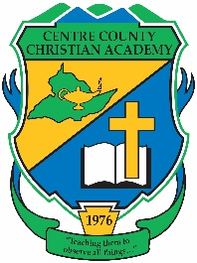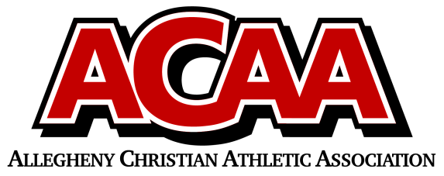

Centre County Christian Academy

Team Colors: Green & Gold

Wins ______ Losses _______ Ties ______

Opponent: ___________________________

Date: ______________________

|  |  |  |  |  |  |
| --- | --- | --- | --- | --- | --- |
| **Number** | **Name** | **Grade** | **Position** | **Height** | **Homeschool** |
| 30 | Trevor Bickel | 12th | Forward |  |  |
| 3 | Kaden Irvin | 12th | Guard |  |  |
| 22 | Alfred Bennett | 11th | Forward |  |  |
| 12 | Jacob Grove | 11th | Guard |  |  |
| 15 | Micah Hoffman | 11th | Guard |  | X |
| 11 | Sam Sides | 11th | Guard |  |  |
| 23 | Josiah Zimmerman | 11th | Center |  |  |
| 1 | Mitchell White | 9th | Guard |  |  |
| 5 | Ryan Doherty | 9th | Guard |  |  |
| 10 | Jacob Tlumac | 9th | Forward |  |  |
| 24 | Evan Gore | 8th | Forward |  |  |
| 14 | Elliot Pimentel | 8th | Guard |  |  |
| 0 | Grant Smith | 8th | Forward |  |  |
| 2 | Max Federov | 8th | Guard |  | X |
| 13 | Oren Shaffer | 8th | Guard |  |  |
|  |  |  |  |  |  |
|  |  |  |  |  |  |
|  |  |  |  |  |  |

Head Coach: Rick Gilbaugh

Assistant Coaches: Ron White

Kurtis Gilbaugh

Official ACAA League Team Roster. to be submitted to the scorer’s table before each game.